**PRACTICAL 2**

**AIM:** To create the following topology.

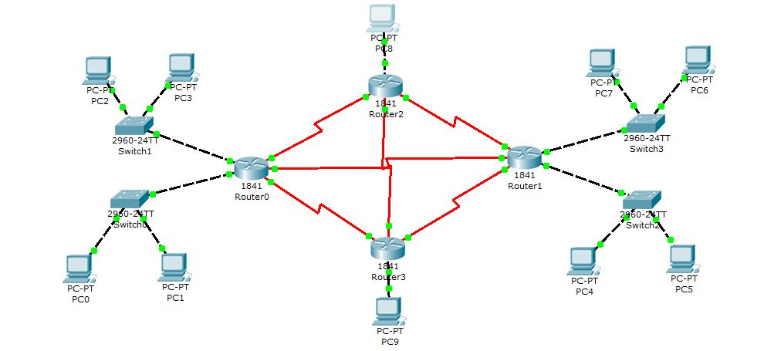

**PC0:**

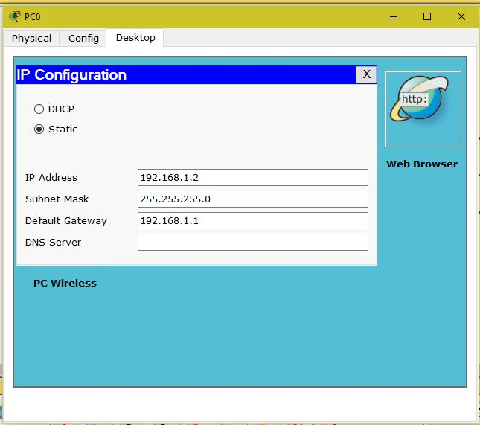

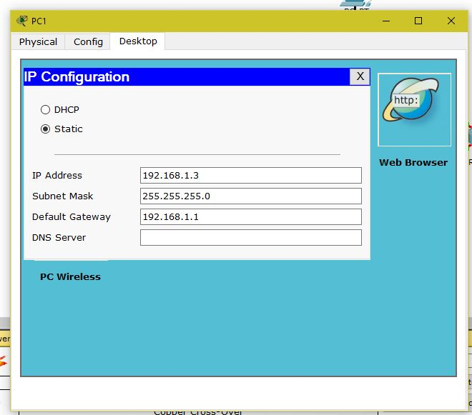

**PC2:**

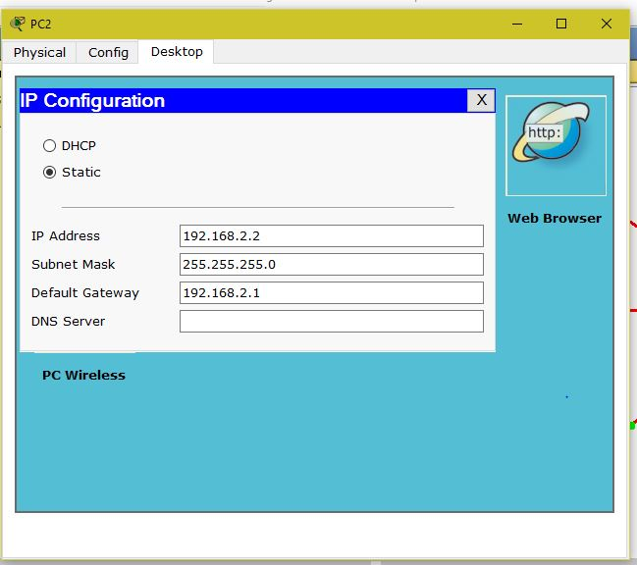

**PC3:**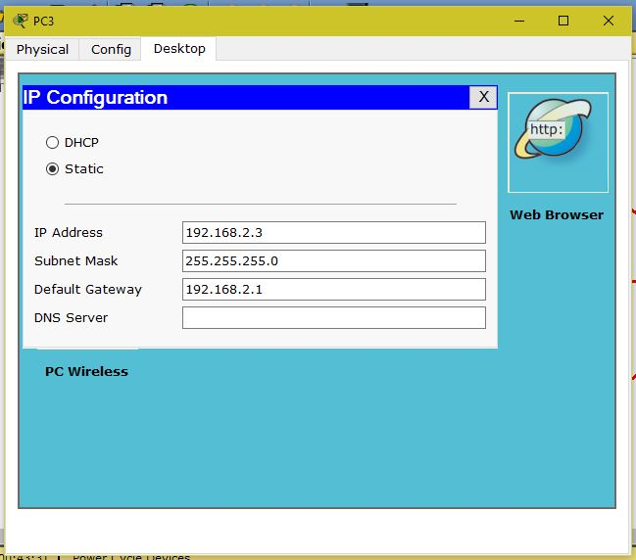

**PC4:**

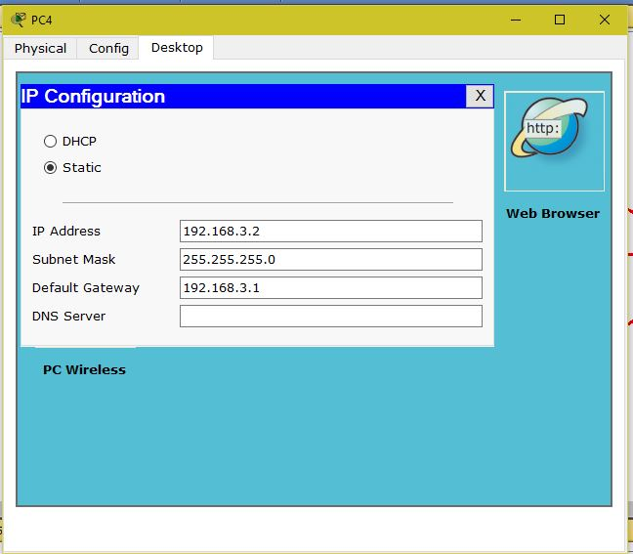

**PC5:**

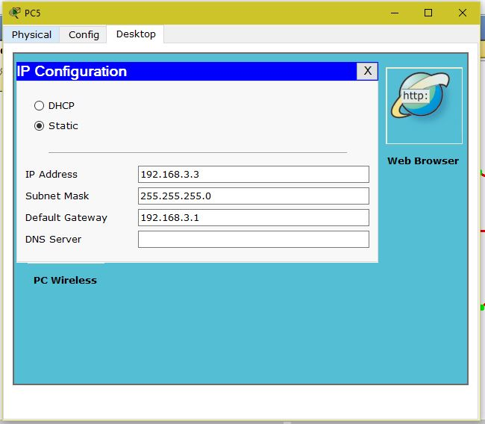

**PC6:**

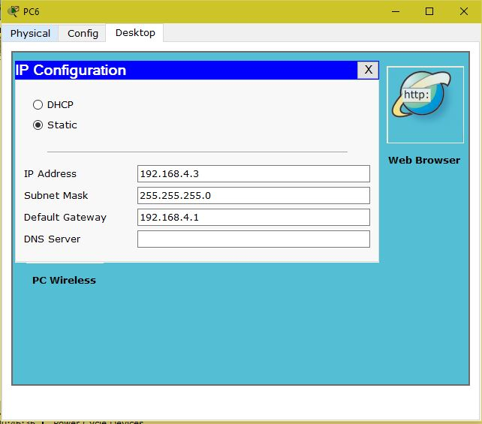

**PC7:**

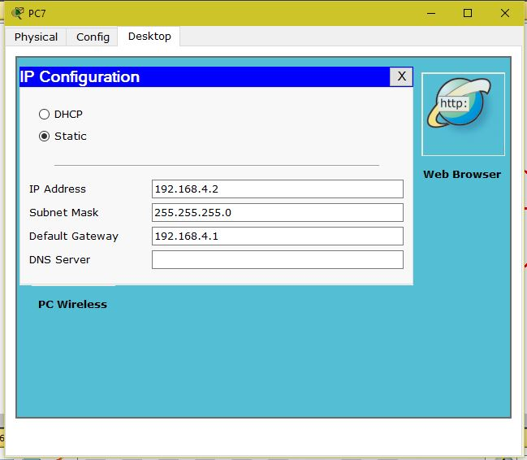

**PC8:**

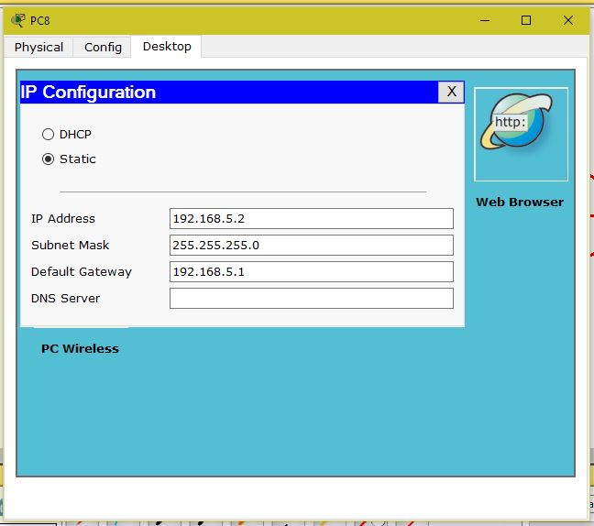

**PC9:**

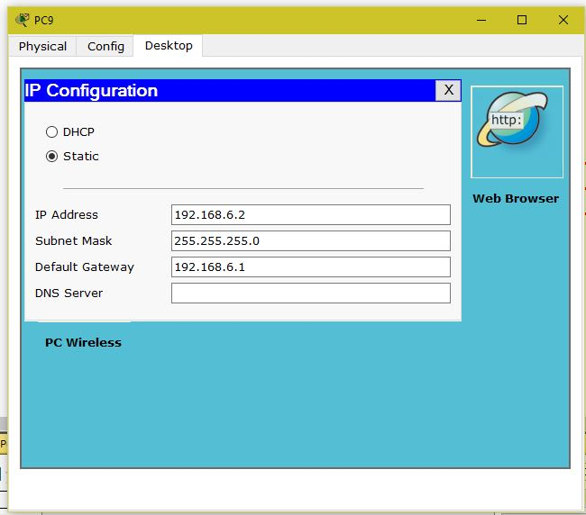

**Router0:**

Router>enable

Router#configure terminal

Enter configuration commands, one per line. End with CNTL/Z.

Router(config)#interface FastEthernet0/0

Router(config-if)#ip address 192.168.1.1 255.255.255.0

Router(config-if)#no shutdown

%LINK-5-CHANGED: Interface FastEthernet0/0, changed state to up

Router(config-if)#exit

Router(config)#interface FastEthernet0/1

Router(config-if)#ip address 192.168.2.1 255.255.255.0

Router(config-if)#no shutdown

%LINK-5-CHANGED: Interface FastEthernet0/1, changed state to up

Router(config)#interface Serial0/0/0

Router(config-if)#ip address 192.168.7.1 255.255.255.0

Router(config-if)#clock rate 128000

Router(config-if)#no shutdown

Router(config-if)#exit

Router(config)#interface Serial0/0/1

Router(config-if)#ip address 192.168.8.1 255.255.255.0

Router(config-if)#clock rate 128000

Router(config-if)#no shutdown

Router(config-if)#exit

Router(config)#interface Serial0/1/1

Router(config-if)#ip address 192.168.9.1 255.255.255.0

Router(config-if)#clock rate 128000

Router(config-if)#no shutdown

**Router1:**

Router>enable

Router#configure terminal

Enter configuration commands, one per line. End with CNTL/Z.

Router(config)#interface FastEthernet0/0

Router(config-if)#ip address 192.168.3.1 255.255.255.0

Router(config-if)#no shutdown

%LINK-5-CHANGED: Interface FastEthernet0/0, changed state to up

%LINEPROTO-5-UPDOWN: Line protocol on Interface FastEthernet0/0, changed state to up

Router(config-if)#exit

Router(config)#interface FastEthernet0/1

Router(config-if)#ip address 192.168.4.1 255.255.255.0

Router(config-if)#no shutdown

%LINK-5-CHANGED: Interface FastEthernet0/1, changed state to up

Router(config)#interface Serial0/0/1

Router(config-if)#ip address 192.168.8.2 255.255.255.0

Router(config-if)#clock rate 128000

Router(config-if)#

%LINK-5-CHANGED: Interface Serial0/0/1, changed state to upno shutdown

Router(config-if)#

%LINEPROTO-5-UPDOWN: Line protocol on Interface Serial0/0/1, changed state to up

Router(config-if)#exit

Router(config)#interface Serial0/0/0

Router(config-if)#ip address 192.168.9.1 255.255.255.0

Router(config-if)#clock rate 128000

Router(config-if)#no shutdown

Router(config-if)#exit

Router(config)#interface Serial0/1/1

Router(config-if)#ip address 192.168.10.1 255.255.255.0

Router(config-if)#clock rate 128000

Router(config-if)#no shutdown

**Router2:**

Router>enable

Router#configure terminal

Enter configuration commands, one per line. End with CNTL/Z.

Router(config)#interface FastEthernet0/0

Router(config-if)#ip address 192.168.5.1 255.255.255.0

Router(config-if)#no shutdown

%LINK-5-CHANGED: Interface FastEthernet0/0, changed state to up

%LINEPROTO-5-UPDOWN: Line protocol on Interface FastEthernet0/0, changed state to up

Router(config-if)#exit

Router(config)#interface Serial0/1/0

Router(config-if)#ip address 192.168.7.2 255.255.255.0

Router(config-if)#clock rate 128000

Router(config-if)#no shutdown

%LINK-5-CHANGED: Interface Serial0/1/0, changed state to up

%LINEPROTO-5-UPDOWN: Line protocol on Interface Serial0/1/0, changed state to up

Router(config-if)#exit

Router(config)#interface Serial0/0/0

Router(config-if)#ip address 192.168.11.1 255.255.255.0

Router(config-if)#clock rate 128000

Router(config-if)#no shutdown

Router(config-if)#exit

Router(config)#interface Serial0/1/1

Router(config-if)#ip address 192.168.10.2 255.255.255.0

Router(config-if)#clock rate 128000

Router(config-if)#no shutdown

%LINK-5-CHANGED: Interface Serial0/1/1, changed state to up#

%LINEPROTO-5-UPDOWN: Line protocol on Interface Serial0/1/1, changed state to up

**Router3:**

Router>enable

Router#configure terminal

Enter configuration commands, one per line. End with CNTL/Z.

Router(config)#interface FastEthernet0/0

Router(config-if)#ip address 192.168.6.1 255.255.255.0

Router(config-if)#no shutdown

%LINK-5-CHANGED: Interface FastEthernet0/0, changed state to up

%LINEPROTO-5-UPDOWN: Line protocol on Interface FastEthernet0/0, changed state to up

Router(config-if)#exit

Router(config)#interface Serial0/1/0

Router(config-if)#ip address 192.168.9.2 255.255.255.0

Router(config-if)#clock rate 128000

Router(config-if)#no shutdown

%LINK-5-CHANGED: Interface Serial0/1/0, changed state to up

%LINEPROTO-5-UPDOWN: Line protocol on Interface Serial0/1/0, changed state to up

Router(config-if)#exit

Router(config)#interface Serial0/0/0

Router(config-if)#ip address 192.168.11.2 255.255.255.0

Router(config-if)#clock rate 128000

Router(config-if)#no shutdown

%LINK-5-CHANGED: Interface Serial0/0/0, changed state to up

%LINEPROTO-5-UPDOWN: Line protocol on Interface Serial0/0/0, changed state to up

Router(config-if)#exit

Router(config)#interface Serial0/1/1

Router(config-if)#ip address 192.168.12.2 255.255.255.0

Router(config-if)#clock rate 128000

Router(config-if)#no shutdown

%LINK-5-CHANGED: Interface Serial0/1/1, changed state to up

%LINEPROTO-5-UPDOWN: Line protocol on Interface Serial0/1/1, changed state to up

**IP Route:**

**Router0:**

Router(config)#ip route 192.168.3.0 255.255.255.0 192.168.8.2

Router(config)#ip route 192.168.4.0 255.255.255.0 192.168.8.2

Router(config)#ip route 192.168.5.0 255.255.255.0 192.168.7.2

Router(config)#ip route 192.168.6.0 255.255.255.0 192.168.9.2

**Router1:**

Router(config)#ip route 192.168.1.0 255.255.255.0 192.168.8.1

Router(config)#ip route 192.168.2.0 255.255.255.0 192.168.8.1

Router(config)#ip route 192.168.5.0 255.255.255.0 192.168.10.2

Router(config)#ip route 192.168.6.0 255.255.255.0 192.168.12.2

**Router2:**

Router(config)#ip route 192.168.1.0 255.255.255.0 192.168.7.1

Router(config)#ip route 192.168.2.0 255.255.255.0 192.168.7.1

Router(config)#ip route 192.168.3.0 255.255.255.0 192.168.10.1

Router(config)#ip route 192.168.4.0 255.255.255.0 192.168.10.1

Router(config)#ip route 192.168.6.0 255.255.255.0 192.168.11.2

**Roter3:**

Router(config)#ip route 192.168.1.0 255.255.255.0 192.168.9.1

Router(config)#ip route 192.168.2.0 255.255.255.0 192.168.9.1

Router(config)#ip route 192.168.3.0 255.255.255.0 192.168.12.1

Router(config)#ip route 192.168.4.0 255.255.255.0 192.168.12.1

Router(config)#ip route 192.168.5.0 255.255.255.0 192.168.11.1

**Output:**

